What the ‘manage cover’ page shows as parts of a day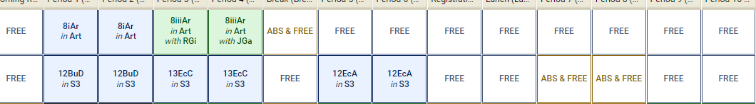

What the ‘create absence’ page allows:

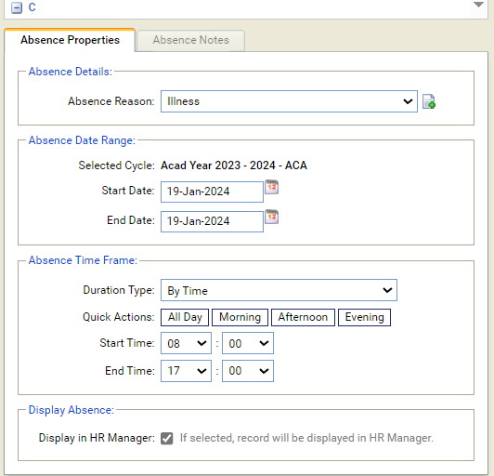

Leave ‘start / end’ times here (though it would be much more helpful if you just had one box to type into, e.g. “12.45” rather than “12” (click next box) “45”)

Add underneath the elements of the school day,as pulled through from ‘parts of the day’ in timetable manager’

For us that would be:

* Registration
* Period 1
* Period 2
* Period 3
* Period 4
* Break
* Period 5
* Period 6
* Registration
* Lunch
* Period 7
* Period 8
* Period 9
* Period 10