Problem :

The **notification email (Figure 2)** does not include any contact information for the guest user enquirer which means the admissions team does not know who the enquiry is from. **Can the merge fields available on the parent notifications tab be added to the User Notification tab?**

Figure

Currently, Admissions staff notification email recipient doesn’t know who is making this enquiry. See example email received by admissions staff below (Figure 2).

Figure

The current User Notification tab does not allow for merged fields. 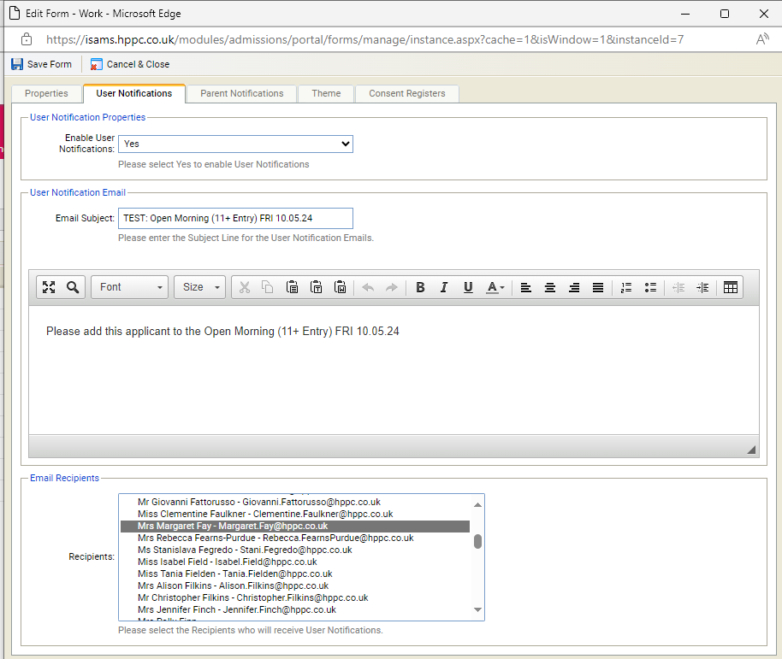

Figure 3

Many thanks,

Margaret Fay