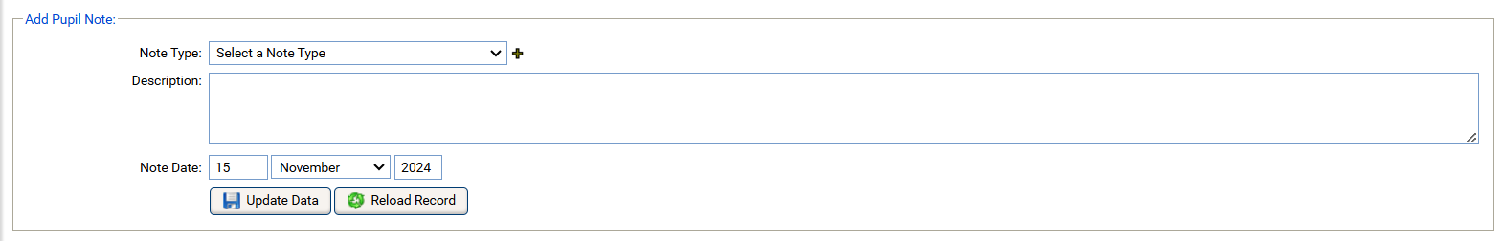
Free Text field max 100 Characters. Editable
Location:
Dropdown: Number in time format (hh:mm) set in 15 minute increments to a maximum of 5 hours (00:00-05:00). Editable
Hours Offered:
Contact Duration:
Dropdown: Number in time format (hh:mm) set in 15 minute increments to a maximum of 5 hours (00:00-05:00). Editable

Editable Time Stamp field, just like the “Note Date”
Note Time:

