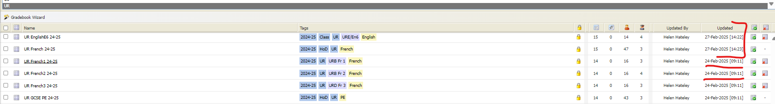

Gradebook List – Point at the Gradebook needs to highlight the row



List View

