**VARIOUS IDEAS TO HELP ALL STAFF**

3. Being able to open the students medical record (if permission allows) from the calendar appointment. Allowing easy access and save time.

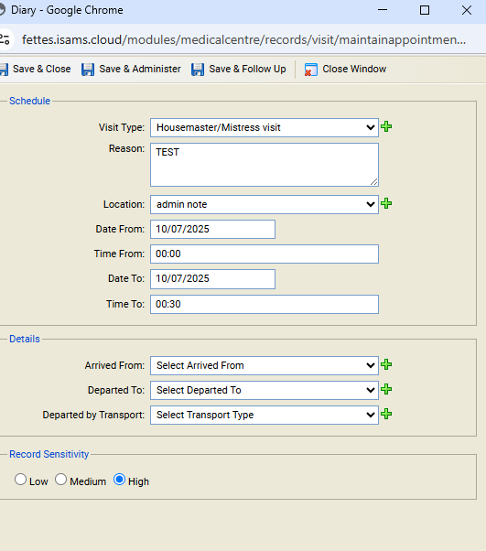

If there was an option on this screen to open the students medical nores (with correct permission), it would stop the need to go into the other tab and search for the student:  
For example checking consents before administering medication or   
