– student: **I**ad NO\*\*\***

Attendance CTF / XML file from previous school: 8944005_CTF_our school.001

(from New Road Academy) Contains previous historical attendance

Not sure if attendance is importing in. It is definitely not showing up in any historic attendance reports or on the XML file we export out of Edgen.

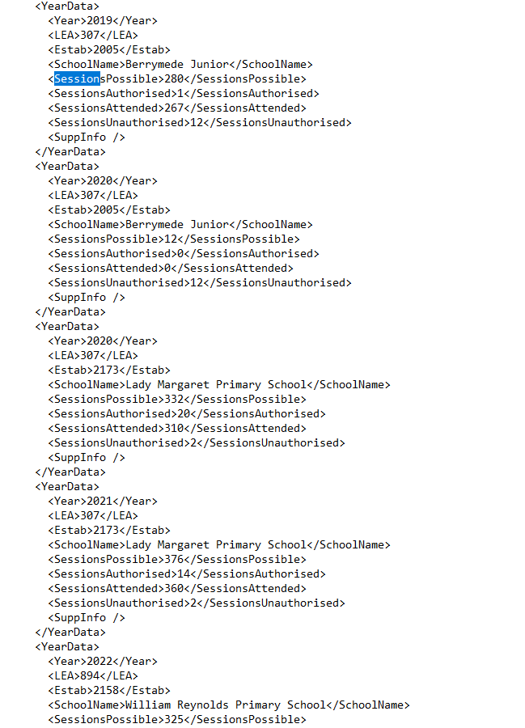

The CTF/XML file from previous school was imported in Admission Manager|applicants | Import

Then I exported CTF out of Edgen.

XML TEST FILE (312XXXX_CTF_312XXXX_003) OUT OF EDGEN DOES **NOT** INCLUDE HISTORICAL **ATTENDANCE**

BUT DOES HOWEVER, INCLUDES SCHOOL HISTORY

We are not meeting our statutory duty if we cannot maintain complete history of attendance within Edgen via CTF file. Interesting how other schools' XML files exports contains complete history of attendance for every academic years (and from different schools, including primary).

**SCHOOL HISTORY IMPORTS HAS IMPORTED INTO EDGEN:**

