Alumni API – Leaving Year Group
The ‘Leaving Year group’ field should be available in the Student Manager – Alumni API.
The field is visible in the ‘Student Manager’ screen. See this example from your online documentation.
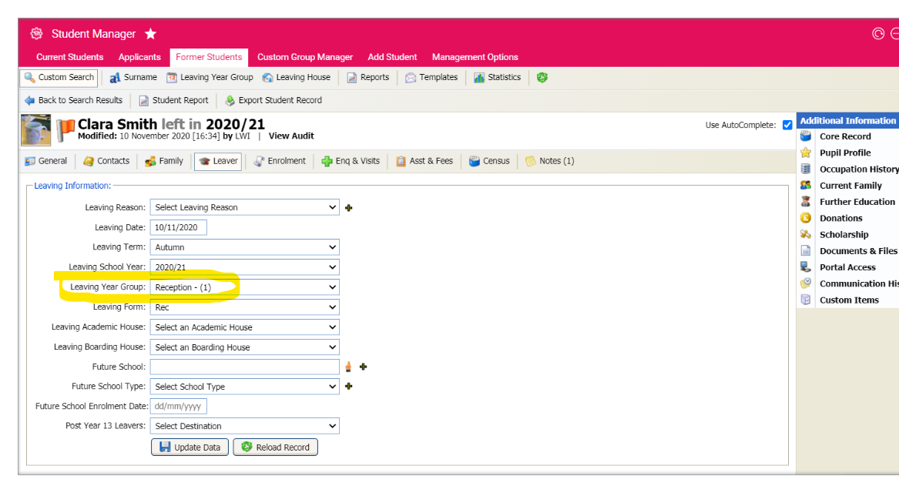
However, when you extract the Alumni information using the BATCH API, the ‘Leaving Year Group’ field is not available.
https://developer.isams.com/isams-developer-documentation/docs/studentmanager-almuni
Note the ‘Leaving Academic House’ and ‘Leaving Boarding house’ are available, but ‘Leaving Year Group’ is not.
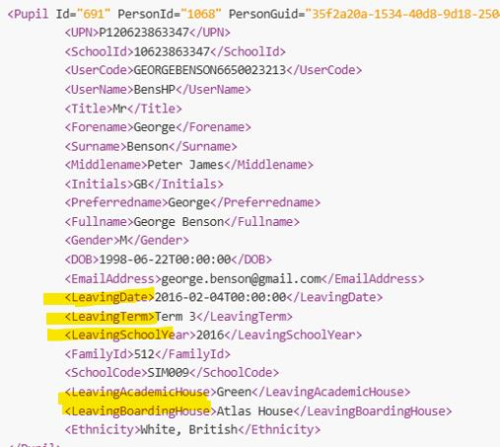

The ‘Leaving Year Group’ field is available in the ‘Student Manager REST API’; however, this only appears to return a list of ‘On Roll’ students, not Leavers or Alumni.

If this API returned ‘ALL Students’, including leavers, that would solve the problem as we can filter the leavers out separately.
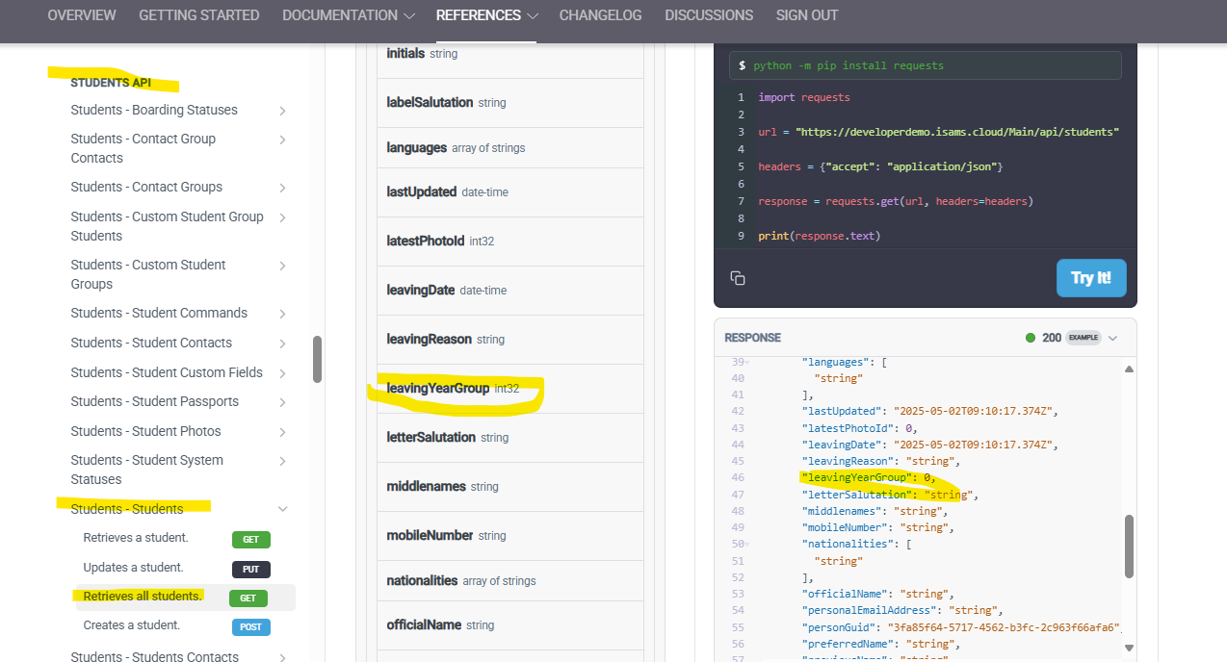
You can extract a list of leavers using the REST API endpoint, ‘Admissions – Alumni’, but that does not return the ‘Leaving Year Group’ field either. It only returns ‘Enrolment Year Group’.
https://developer.isams.com/isams-developer-documentation/reference/applicantalumni_getallbypagepagesize-1
