PP Status column activated in Preferences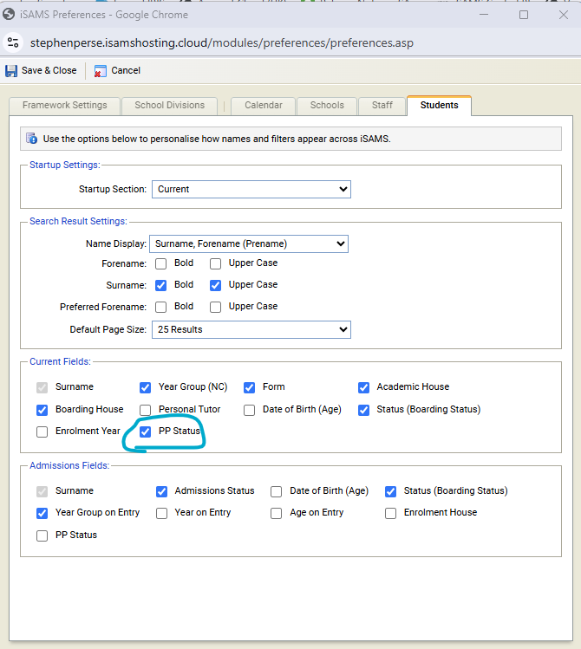

PPS column showing in Student Manager (screenshot narrowed to hide personal details)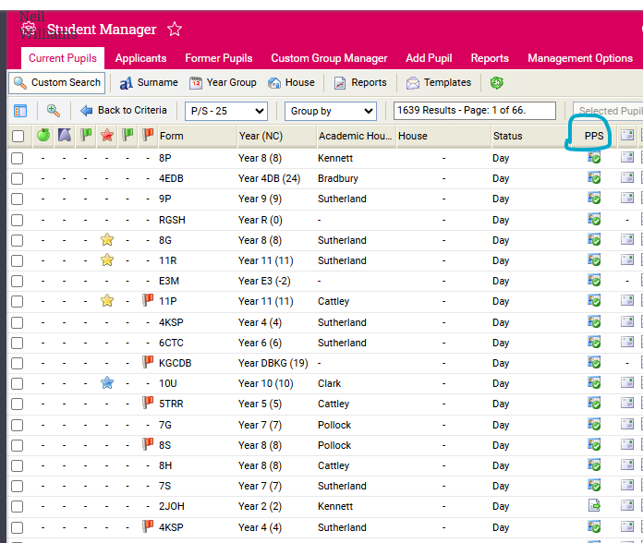

Current PPS icons



|  |  |  |
| --- | --- | --- |
| Icon | Current Meaning | Suggested Meaning |
|  | At least one contact has an active Parent Portal login | All invited contacts have activated their Portal login |
|  | Invitations have been issued, but no one has activated their account | Invitations have been issued, but no one has activated their account |
|  | No invitations have been issued | No invitations have been issued |
| or similar | *N/A* | Some, but not all invited contacts have activated their account |