Subject results are spread out because of lengthy comments.

If user has an option for comments to be displayed or not it would help.

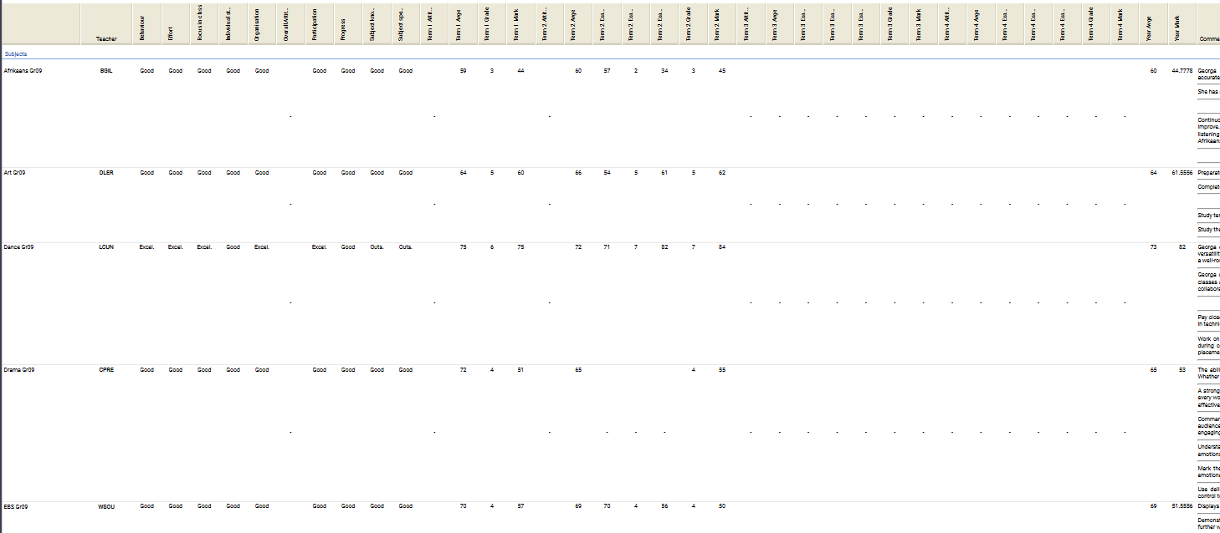

When comments are not so long, results are easier to view.

