Rewards and Conduct Manager

Reports

Filter options include Subject, Type of category, Grade and House BUT no option available for PASTORAL Tutor – is this a setting we can amend or do I have to log it on the Ideas portal?

Thank you

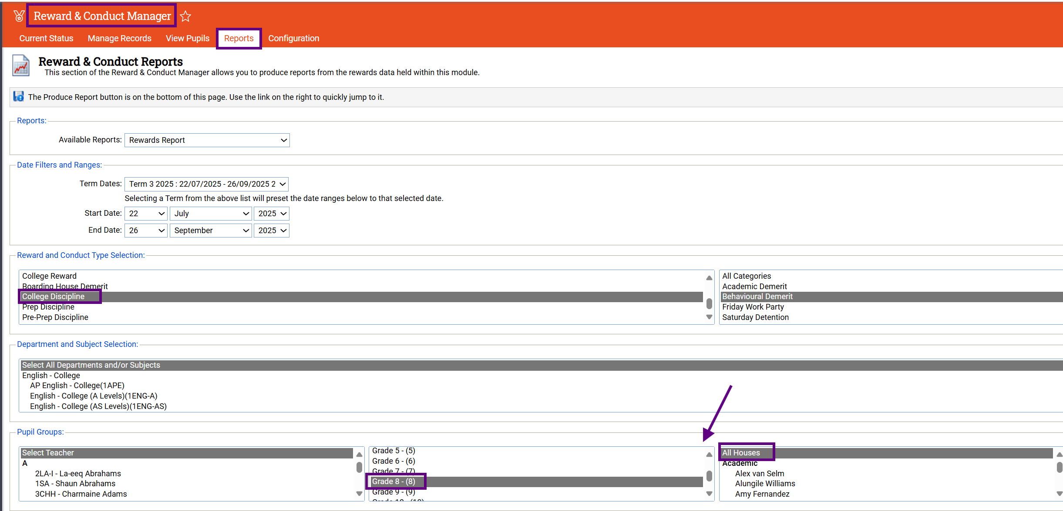

It would be enormously helpful if PASTORAL Tutor was included here